*Reference figure 1 – specimen shape*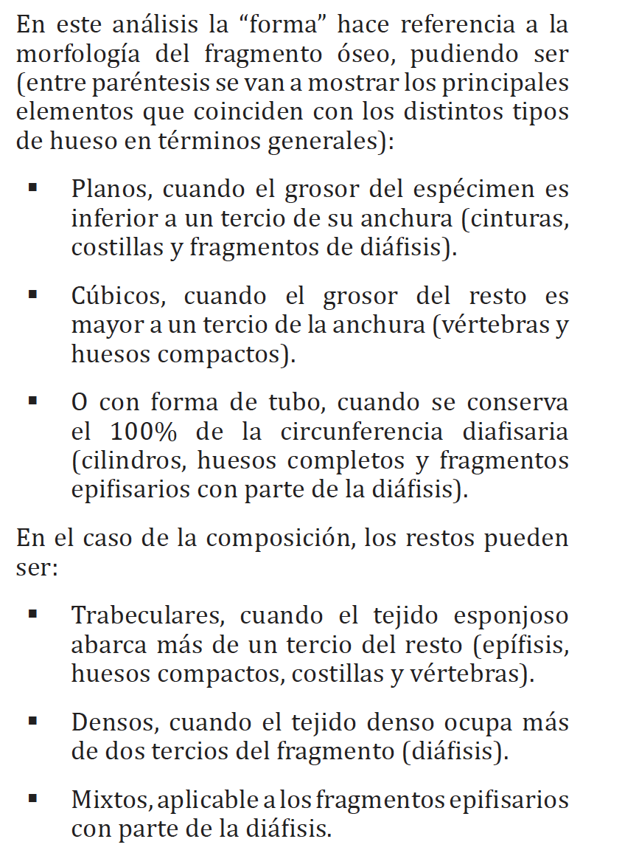

*Reference figure 2.1 (Antonio) – animal size*

*Reference figure 2.2 (Abel) – animal size*

*Reference figure 3 - Manganese*

*Reference figure 4 – Rounding and polished*

**Hot and Cold Zones** (Domínguez-Rodrigo et al. 2007, Deconstructing Olduvai)

*Maasai Mara*

*Reference figure 5 – Hot and cold zones*

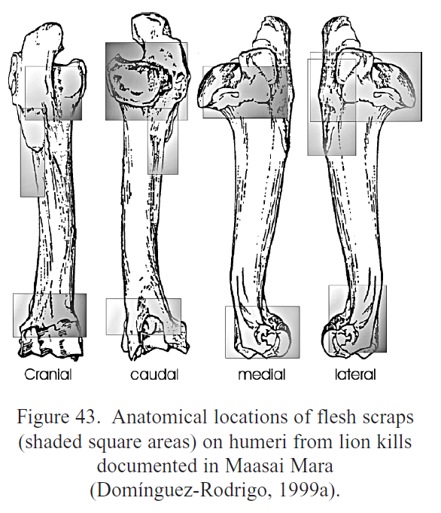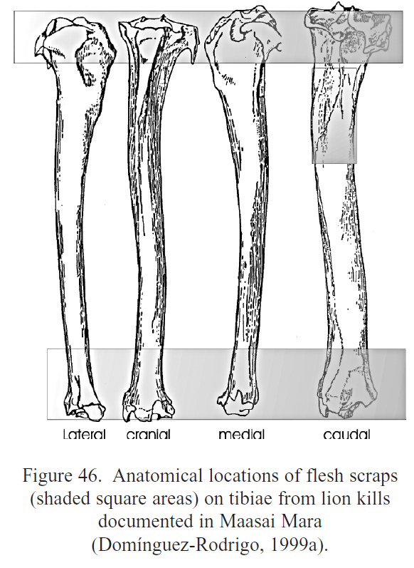

*Galana and Kulalu*

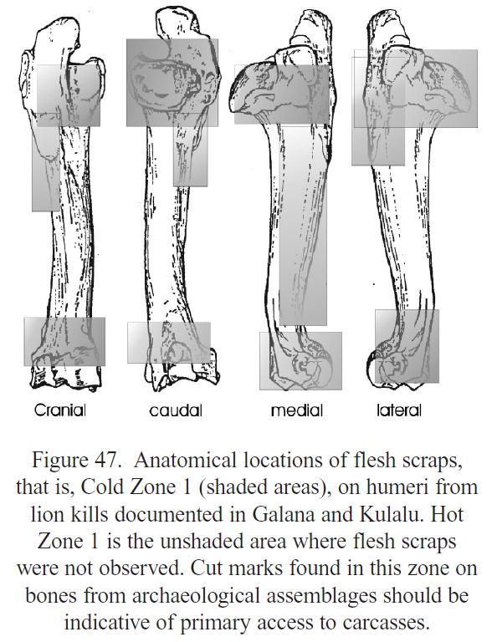 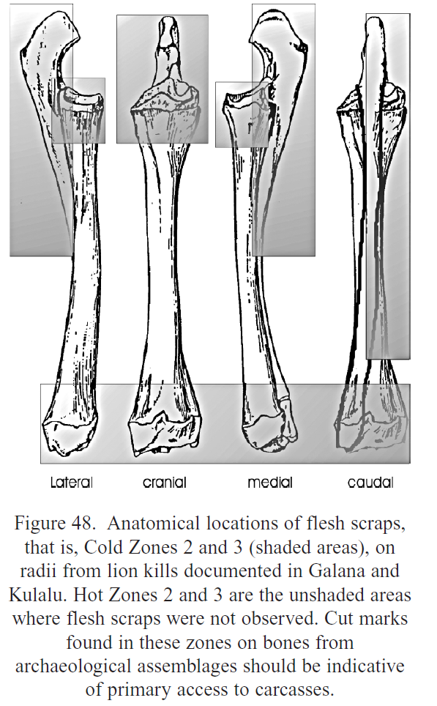

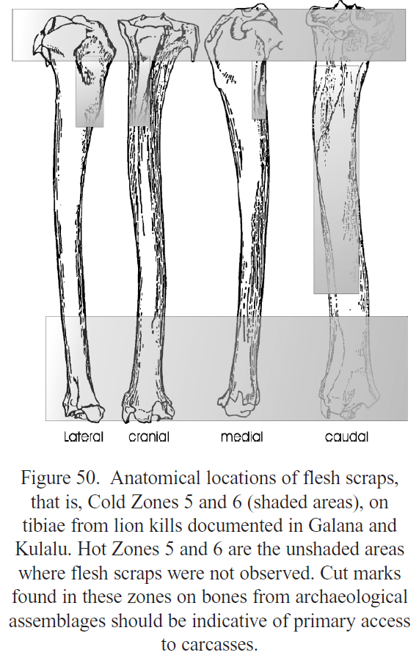

**Taphotypes** (Domínguez-Rodrigo et al. 2015)

*Classification System I*

*Reference figure 6 - Taphotypes*

*Classification System II*

